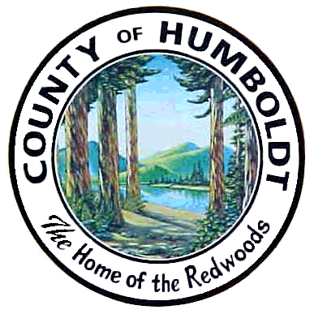 COUNTY ADMINISTRATIVE OFFICE
RISK MANAGEMENT DIVISION
COUNTY OF HUMBOLDT
825 Fifth Street, Room 131
Eureka, CA 95501
(707) 268-3669 Fax: (707) 268-2546

May 3, 2011

Hank Sims
New Media Director/Co-director of News
Lost Coast Communications

Re: Public Records Request Dated: April 7, 2011

Dear Mr. Sims:

I am responding to your e-mail to the County Administrative Office and received by this office on April 7, 2011 requesting any copies of records released as part of the PRA request submitted by Shirley Fuller pursuant to California Government Code §. In regards to the records you requested:

- All e-mail communications sent by Supervisor Mark Lovelace on April 1 to April 4, 2011.

Response: The County has located disclosable public records that are responsive to this request and is able to provide you with electronic versions of communications sent by Supervisor Mark Lovelace between April 1 and April 4, 2011. Those disclosable records are attached to this responding email. In addition, the County has located records which are exempt from disclosure pursuant to the Public Records Act, Government Code section 6254 (k) including but not limited to attorney-client privilege and attorney-work product. In addition, please note some of the disclosable records provided to you have been redacted to protect personal information contained in the emails.

- All e-mail communication sent or received by any County e-mail account on April 1 to April4, 2011 with a subject line that contains the word “HELP”.

Response: Due to the broad scope of your request and the County’s significant number of email addresses (mailboxes), and the County’s technology infrastructure the County is unable to reduce a computer search to the subject line containing the word “HELP”. Therefore, the County is unable to conduct a search to determine if there are disclosable records responsive to your request.

- All e-mail communication sent or received by any County e-mail account during the past nine months where the recipient or sender of the communication was one of the following e-mail addresses/domains (requested domains will be listed with an “@” at the beginning to signify any e-mail address within that domain):
- humboldtherald@gmail.com
- @humboldtbaykeeper.org
- @yournec.org
- @duhc.org
- @healthyhumboldt.org
- @thegreenlivingcenter.com
- mmckinney@humboldt1.com
- greggigold@netscapel.net
- Eaf7@humboldt.edu
- dfbeck@northcoast.com
- @green-wheels.org
- jkalt@as-is.com
- @cnps.org

Response: Due to the broad scope of your request and the County’s significant number of email addresses (mailboxes), and technology infrastructure the County is unable to reduce a computer search to the specific individual addresses above. Therefore, the County is unable to conduct a search to determine if there are disclosable records responsive to your request.

If you require anything further please address your request to County of Humboldt, Risk Management, 825 5th Street, Room 131, Eureka, CA 95501 or feel free to email jgath@co.humboldt.ca.us

Very truly yours,
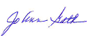
Jo Ann Gath
Risk Manager

