“Angels in Orange”
Service and Rehabilitation in the Conservation Camps of Humboldt County

SUMMARY
The Humboldt County Civil Grand Jury (Civil Grand Jury) annually visits and evaluates the physical condition and management of public prisons and may inspect other holding facilities located throughout the county. This year the Civil Grand Jury inspected the Humboldt County Correctional Facility, Humboldt County Juvenile Hall, Northern California Regional Center, High Rock Conservation Camp, Eel River Conservation Camp (State Conservation Camps are the only prisons in Humboldt County), and Sempervirens Psychiatric Health Facility.
This report describes the Civil Grand Jury’s inspection and evaluation of Humboldt County’s two Conservation Camps. We found both Camps to be well-maintained and well-managed. Inmates volunteer for assignment to the Camps. Camp inmates are provided an opportunity to learn skills and function in communal activities that teach them life skills and prepare them for re-entry to society. The Camps provide great opportunities for rehabilitation, where inmates learn job skills, develop self-discipline and gain self-respect. Camp crews provide important firefighting forces during the state’s ever-expanding fire season and community service activities during the non-fire season.
The Civil Grand Jury was impressed with the positive aspects of rehabilitation provided by the camps as well as the great service the camps provide to the communities. Unfortunately, the camps are understaffed by inmates due to changes in housing and sentencing guidelines which limit inmates to serve time in institutions which lack the rehabilitative benefits found in service at the camps.
California Department of Corrections and Rehabilitation maintains and publishes thousands of data points related to their operations. However, there is insufficient data being collected and published regarding Conservation Camp social equitability and rehabilitative effectiveness.

BACKGROUND
The Humboldt County Civil Grand Jury’s mandate to conduct inspections of management and condition of custody facilities is rooted in the State Constitution. The grand jury is one of the oldest civil institutions in America and has been part of California law since statehood in 1850. County civil grand juries are required by the State Constitution (California Constitution, Article 1, Section 23, 1850). The grand jury is an independent body and, as an instrument of the court, subject only to the court’s jurisdiction. The primary function of civil grand juries is to act as the public watchdog by investigating and reporting on affairs of local government. As part of this watchdog mandate, the civil grand jury annually visits and evaluates the physical condition and management of public prisons (State Conservation Camps are the only prisons in Humboldt County) and may inspect holding facilities located throughout the county (California Penal Code, Section 919(b)). This includes county jails, state prisons and work camps, or any place in the county a prisoner may be taken, including all police stations and county work sites.
There are 42 Conservation Camps in 27 counties throughout California. Eel River and High Rock are the two Conservation Camps in Humboldt County. The California Department of Corrections and Rehabilitation (CDCR) started camps in 1915. Camps started fighting fires during World War II. Currently, there are about 3,500 positions for inmates at camps. Of those positions, about 2,150 are firefighters, the rest are inmates acting as support personnel. Not all of those inmate positions are filled. During the 2019 fire season, 18 16-person crews in the 18 northern California Camps were not staffed due to a shortage of qualified inmates. Statewide inmates provide about three million hours per year on emergency incidents and about seven million hours per year on community service projects. The inmates at Camps provide over $100 million of service to the state each year.
An inmate’s sentence is reduced more quickly while working in the Camps and inmates are compensated for their work. Of greater value to the inmate are the knowledge, skills, and abilities they learn at the Camps, where inmates develop self-respect and self-discipline through their experiences at the Camps. The communities they have saved have often called the inmate fire crews “Angels in Orange.”

METHODOLOGY
Members of the Humboldt County Civil Grand Jury conducted inspections and interviews at the following locations:
- Humboldt County Correctional Facility
- Humboldt County Juvenile Hall
- Northern California Regional Center
- Sempervirens Psychiatric Health Facility
- California Department of Corrections and Rehabilitation, Eel River Conservation Camp (#31)
- California Department of Corrections and Rehabilitation, High Rock Conservation Camp (#32)
Additional research of both print, internet sources, and follow up interviews were conducted to confirm and clarify details.

DISCUSSION
California Department of Corrections and Rehabilitation Conservation Camps in Humboldt County
Conservation Camp 31, Eel River Conservation Camp
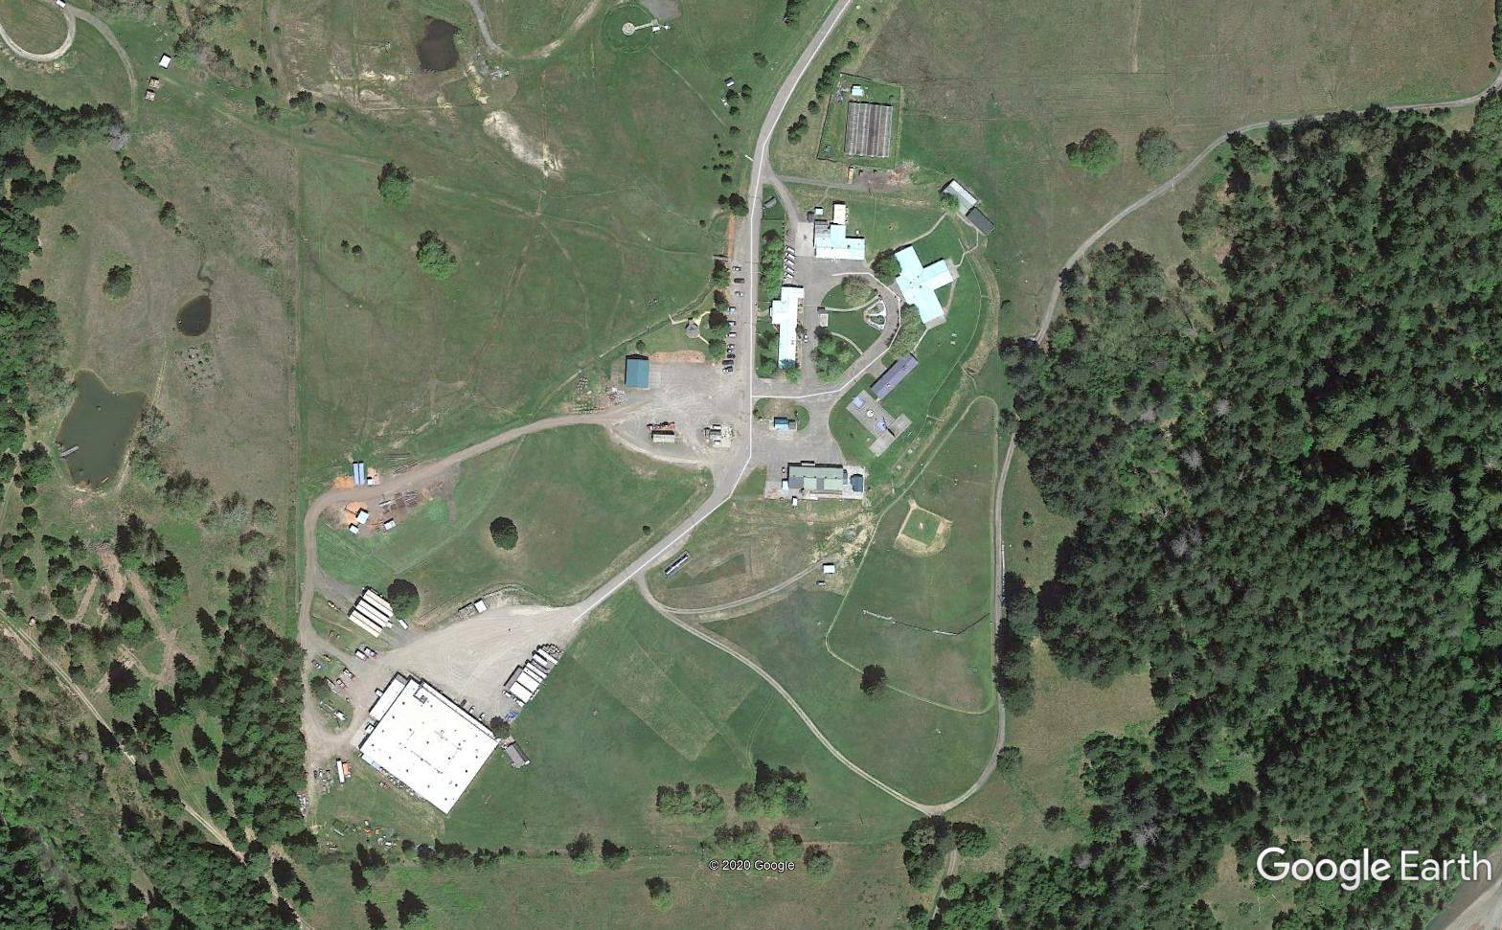
Google Image of Eel River Conservation Camp
Eel River Conservation Camp near Redway was activated February 2, 1967 as a joint operation between California Department of Corrections and Rehabilitation (CDCR), currently staffed with eleven personnel, and the California Department of Forestry and Fire Protection (CalFire), currently staffed with 14 personnel. This camp can house 132 inmates and currently houses 71 inmates.

Conservation Camp 32, High Rock Conservation Camp
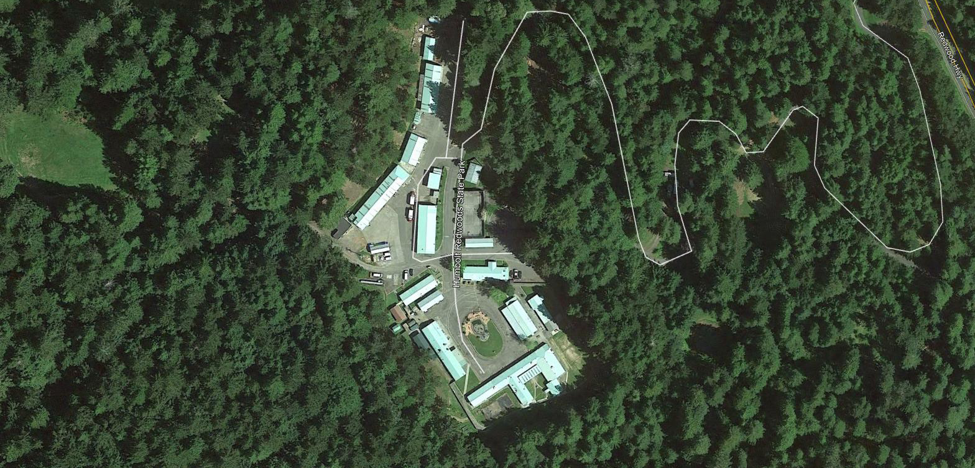
Google Image of High Rock Conservation Camp
High Rock Conservation Camp in Humboldt Redwoods State Park near Weott was established in 1954, as a joint operation between California Department of Corrections and Rehabilitation (CDCR), currently staffed with nine personnel, and the California Department of Forestry and Fire Protection (CalFire), currently staffed with 12 personnel. This camp can house 110 inmates and currently houses 68 inmates.

Life in the Conservation Camps

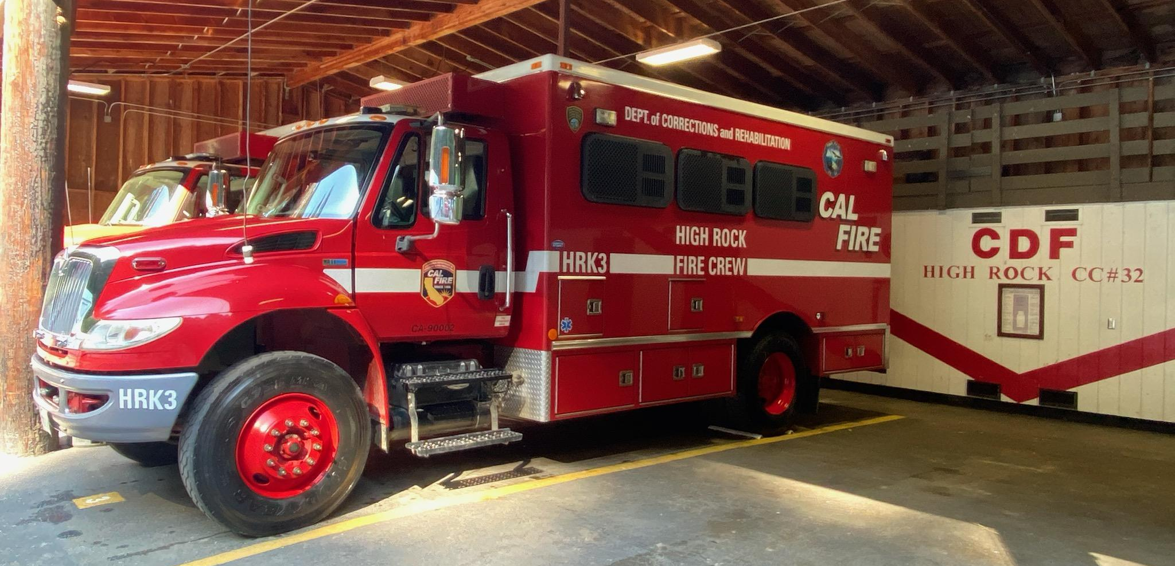
Photo of High Rock Conservation Camp Crew Bus

The primary task for inmates at the Conservation Camps throughout the state is to provide fire crews and inmate hand crews for fighting wildland fires during summer and fall fire seasons. Their mission includes improving the safety and quality of life to state residents while providing inmates with a rehabilitative environment to develop the skills and discipline to become successful members of society upon release. During the winter months the crews’ primary function is to clear roadsides of brush and low-hanging trees, thereby promoting fire prevention.
If an inmate meets the security risk level that qualifies them for service at the camps the inmate can volunteer to participate in the camp system. They must pass a medical evaluation and then participate in a two-week physical fitness program. To be assigned to a fire crew they must pass the medical exam and the physical fitness program. If they are not medically or physically fit for a fire crew they may still qualify to serve a support role at the camps. After a potential inmate firefighter has passed the physical fitness program, the inmate is transferred to CalFire instructors who will provide wildland fire training. Having passed the six to seven week process of fire service training, the inmate will then be assigned to a camp fire crew.
When not fighting fires inmates also assist in disaster recovery for earthquakes and floods and perform manual labor in conservation and community service projects for various local, county, and state agencies. It is estimated each camp saves the State, after expenses, in excess of $1 million per camp annually. The rehabilitative function of the camp is priceless. Teamwork of the multi-ethnic crews fosters cooperation, co-existence, and responsibility, in stark contrast to the rigid racial divisions of state prison life. Rehabilitation outcomes include development of self-discipline, accountability, the importance of being on-time, and the benefits of positive crew interaction. All of these factors provide for reintegration into society.
Camp staff shared many stories of former inmates’ successful transition to productive employment as contributors to society. They listed a number of inmates that have gone on to work as federal, state, or private firefighters. Other types of employment opportunities are also available to former camp inmates. One non-firefighter inmate told us he was working in the camp as a clerk and he had a job offer as a clerk for the Forestry and Fire Recruitment Program. Another inmate described the training he was getting as a diesel mechanic maintaining fire apparatus with the expectation of gaining employment as a mechanic upon release.
Inmate hand crews have provided conservation activities for State parks, public schools, State, city and county roadways, as well as federal land improvements. They donate firewood to seniors annually and run an in-camp cabinet shop to learn skills and deliver quality wood products. Most of the wood used in the cabinet shop is milled from fallen trees in the area. This program saves the State money by manufacturing cabinets, tables, and chairs. The inmate crews also are responsible for the numerous Memorial Grove signs that are posted in the regional State Parks and the Avenue of the Giants. Inmates maintain vegetable gardens on site which reduce the cost of food for the camp while providing wholesome food. Inmate programs for rehabilitation include alcohol and drug education, religious faith-based services, acquiring DMV ID and Driver license in preparation for release, crafts and hobbies, in-camp gardening, and music appreciation with access to guitars and keyboards for musical exploration and creativity.
An inmate’s sentence is reduced two days for every day the inmate is assigned to a camp. Inmates can earn $2.90 to $5.12 per day (depending on skill level and assignment) and make an additional $1 per hour when on emergency incidents. Of greater value to the inmate is the knowledge, skill, and experience they gain at the camps. Inmates also have the opportunity to serve the community which brings them self-respect and self-discipline. The communities they have saved have often called the inmate fire crews “Angels in Orange.”

Shortages in Eligible Inmate Volunteers

The inmate classification system identifies inmates who may volunteer to serve in the Conservation Camps. Inmates are placed on different classification levels through a points system based on the seriousness of the crime and the inmate’s behaviour while in custody. The Legislative Analyst’s Office report, Improving California’s Prison Inmate Classification System states:
“Inmates Assigned Housing Score Based on Their Risk of Misconduct. When inmates arrive at a prison reception center following sentencing, they receive a risk assessment in which they are assigned points totaling from 0 to 999 based on six factors that are statistically associated with in‑prison misconduct. These factors are (1) age at first arrest, (2) age at time of assessment, (3) term length, (4) gang membership, (5) number of prior incarcerations, and (6) behavior during prior incarcerations.”

Only Level 3 (or lower in points) inmates are qualified to volunteer for Conservation Camps. Inmates with records of arson, violence, rape, or murder as part of their charges are not eligible to be in the Conservation Camp program.
Changes in sentencing and the realignment of inmates as mandated by AB-109 (2011) and Propositions 47 (2014) and 57 (2016) have adversely affected enrollments in the Conservation Camps. This legislation to reduce the state’s prison population has transferred prison inmates serving time for nonviolent felonies, who were previously the most likely candidates for attending the Camps, to county facilities.
In Humboldt County, inmates subject to such realignment and who also qualify for service in the Conservation Camps are typically funneled into the Humboldt County Sheriff’s Work Alternative Program (SWAP) or the roadside maintenance crews. While SWAP and road crews offer some of the same work and training programs as the Conservation Camps, it requires neither an initial training period nor a minimum period of service for eligibility. These requirements are the primary obstacle to assigning inmates from the Humboldt County Correctional Facility to the Camps: only a limited number of inmates have both the required classification and sentences of length sufficient to accommodate the initial training and service periods required by the Camps. It is for these reasons that SWAP and the road crews, rather than the Conservation Camps, is the Sheriff’s preferred work program. The State’s Alternative Custody Program (ACP) and the Non-Custody Return Program (NCRP) are additional programs that provide early release back to the community, often with an ankle monitor.
Such obstacles to maintaining inmate population in the Camps have emerged at the least opportune time for the state of California, where wildland fires are bigger, more frequent, longer lasting, and strike at increasingly earlier points in the state’s annual fire season. This is due, in part, to global climate change and long-term forest management practices that result in unhealthy forests. People are increasingly building and living in wildland areas which puts more lives and property at risk. Long-term neglect of our electrical infrastructure has led to several vegetation fires, property loss, and multiple fatalities.
Failure to keep these Camps fully staffed will result in fewer 16-person hand crews to fight fires, perform fuel reduction activities, and provide other conservation and community services. During the 2019 fire season the 18 Camps in Northern California were unable to staff 18 of the usual number of fire crews due to the shortage of available inmates (288 fewer inmates). Future inmates will not have the opportunity to learn the skills, self-discipline, and self-respect that the Camps instill if sentencing guidelines are not amended to allow inmates the opportunity to serve at the Camps.
Our society is starting to question the efficacy of prison systems. The current philosophy of the California Department of Corrections and Rehabilitation is about providing opportunities for inmates to learn life skills and self-discipline. CDCR’s mission is:
“To facilitate the successful reintegration of the individuals in our care back to their communities equipped with the tools to be drug-free, healthy, and employable members of society by providing education, treatment, rehabilitative, and restorative justice programs, all in a safe and humane environment.”

Conservation Camps help inmates develop in ways that institutions cannot. As in institutions, the Camps can provide opportunities for inmates to earn their GED or take college courses. The Camps also provide opportunities to learn trades and life skills. As examples, an inmate may be able to learn how to operate a chainsaw, fall trees, repair small engines, mill logs, design and build furniture. An inmate can become a diesel mechanic, a cook, a clerk, or certified as a wastewater technician. While some inmates have never held a job before arriving at a Camp they learn the importance of arriving on time and performing as part of a team. The Conservation Camps are the best example of inmates learning skills and self-discipline while providing benefit to the communities.

Rehabilitation in the Camps

There is a remarkable consensus—shared by CDCR administrators, officers supervising the Camps, and the inmates themselves—that the Camps are sites of real, indisputable rehabilitation and have a lasting positive impact on the lives of the inmates and their communities. Rehabilitation through labor and the development of a strong work-ethic are omnipresent in inmates’ personal reflections as preserved in interviews conducted by the Grand Jury and by scholars of various disciplines who have researched the Camps.
It was commonplace for inmates to speak positively of “modifying” themselves or seeking an opportunity for “better living” during their time in the Camps. According to one individual, there was little incentive for an inmate to seek admission to the Camps unless self-improvement was their goal.
Studies have attested that the inmates’ firsthand experience of being acknowledged for their hard work by people from the (often distressed) communities they were helping. One interviewee who spoke with the Grand Jury identified the value of helping the community in his participation in something “bigger than himself.”
In this rehabilitative setting, correctional officers are key figures in reinforcing this new sense of self-worth, as one inmate explained:

“There’s an assembly where we have a formation in the mornings and it was like my second or third day and the lieutenant comes out and he goes, ‘Look, we’ll treat you like men first, firefighters second and prisoners if we have to.’ That right there, that stuck in my head for two years now because now I have a chance to be treated like a man.” (KQED News, July 25, 2014)

The Camps seem to restore the sense of self that the inmate possessed before incarceration. One interviewee described the feeling as a transition “back to being a person” rather than a statistic behind the walls of a conventional correctional facility.

Former Inmates getting Jobs

The CDCR has created a post-incarceration firefighter training program for former inmates known as the Ventura Training Center (VTC). The CDCR website states:
“The California Department of Forestry and Fire Protection (CAL FIRE), California Conservation Corps (CCC) and California Department of Corrections and Rehabilitation (CDCR), in partnership with the Anti-Recidivism Coalition (ARC), have developed an enhanced firefighter training and certification program at the Ventura Training Center (VTC), located at the Ventura Conservation Camp (VNT), in Ventura County. Trainees are former offenders on parole who have recently been part of a trained firefighting workforce housed in fire camps or institutional firehouses operated by CAL FIRE and CDCR. Members of the CCC are also eligible to participate.”

There are multiple examples of former inmates from Conservation Camps becoming employed in federal, state, and private fire service. However, California regulations restrict a person who has been convicted of a felony being certified as an Emergency Medical Technician (EMT). (Each local Emergency Medical Services authority has the ability to waive this requirement, but that is a rare exception.) Therefore, it is not possible for former inmates who were trained and functioned as firefighters to be employed in municipal fire agencies.
Not all inmates are training for jobs in manual labor: one inmate was serving as a clerk in the Camps and had already acquired gainful employment as such after his release. Another inmate was learning to be a diesel mechanic while being supervised working on the fire apparatus. Some camps have an inmate trained and certified as a wastewater technician. Those inmates who perform as wastewater technicians can find permanent, well-paid jobs upon release from custody.

Social Justice and the Camps

The American Civil Liberties Union (ACLU) has objected to what it considers the moral and practical problems of enlisting convicted criminals to perform the dangerous job of wildland firefighting. In response to the deaths of three inmate firefighters killed while working fires in 2016 and 2017, a spokesperson for the organization’s “National Prison Project” suggested that such workers were being exploited by the state by raising doubts about whether prisoners in custody were truly able to volunteer themselves or even be fully cognizant of the risks undertaken in their work. Moreover, the objection considered a participant’s enrollment in such a program as sufficient reason to question the basis for his incarceration: if inmates are permitted to be “running around outside with axes and chainsaws, maybe they didn’t need to be in prison in the first place.”
We believe these objections to be misguided. Not only is participation in the Camps purely voluntary, but that volition is reaffirmed at every stage of the multi-phase process which graduates inmates from incarceration in a traditional institution to actual work in a fire crew. As explained above, the process of an inmate’s path to qualification in the Camps’ points system is sometimes a prolonged one, in which the individual only gradually decreases his or her classification by continued good behavior. After qualifying, inmates then undergo several weeks of both physical fitness training and coursework in organized firefighting and/or the specific trade for which a given inmate has been selected in the Camps. After these requirements have been met, the inmate then joins a fire crew, where his or her commitment to service is affirmed every day by continued participation. Interviews of Camp inmates in published articles attest that many eligible individuals prefer to remain incarcerated in one of California’s traditional correctional institutions.
Assessing the dangers to which inmate firefighters are exposed is difficult due to the limited accessibility of data from primary sources. Data presented by popular media is often piecemeal and selective, which makes its true value difficult to assess. A good illustration of this is a 2018 Time article (Vesoulis) which explains that inmates are (per capita) four times as likely as their professional counterparts to incur “object-induced” injuries (e.g., cuts, bruises, fractures) and eight times as likely to be injured by smoke inhalation. Professional firefighters, the article acknowledges, are nine times more likely than inmates to be burned and twice as likely to suffer heat-related illness. But these figures appear to be confined to those fires for which both inmates and professionals share responsibility for fighting. Vesoulis lacks the data, she admits, to compare overall injury rates between the two groups.
Media attention that has been critical of the Camps in recent years has focused on fatalities on the job, specifically three deaths that occurred from 2016 to 2017. Available evidence suggests that deaths of inmate firefighters are much less frequent than their professional colleagues. These three inmate deaths represent about half of the total number of deaths among inmate firefighters since 1983, a period of nearly 40 years. According to a report by the Federal Emergency Management Agency (FEMA), a total of 144 individuals (including inmates) died fighting wildland fires between 2009 and 2018 across the United States (14.4 average deaths annually). Conservation Camp inmates also have much lower fatality rates than their peers in traditional, walled institutions. A total of 388 inmates died in California prisons in 2017. In 2018, this figure increased to 452, of which 208 were classed as “unexpected” (mostly homicide, suicide, drug overdose, and cardiac arrest). To achieve the CDCR’s mortality rate of .33% of the total prison population over 2017 and 2018 would require between nine and ten inmate deaths annually among the Conservation Camps’ roughly 3,100 total inmates. Statistically it is safer to be in a Conservation Camp rather than in the more conventional state prison setting.
Given the combined weight of the anecdotal and statistical evidence presented above, the Grand Jury disagrees with the ACLU’s characterization of Conservation Camp inmates as exploited laborers forced to serve the state under duress. It also finds the organization’s dismissal of the Camps as proof that such inmates should not be in CDCR custody in the first place—simply because they are entrusted with greater responsibilities than an inmate of a walled facility—to be poorly reasoned. We cannot imagine the ACLU arguing for the outright release of all inmates (e.g., non-violent, white-collar criminals) simply because they can be trusted to work power tools in California’s woodlands.
The Civil Grand Jury believes the diversity of evidence—particularly the inmates’ own accounts of their experience of the Camps—shows that the Conservation Camps fulfill at least three of the four stated goals of the ACLU’s own National Prison Project, which include:
1) Reduction of the incarcerated population
2) Ending cruel and inhumane conditions of confinement
3) Expanding prisoners’ freedom of religion, expression, and association.

First, the Conservation Camps reduce the incarcerated population by allowing participants to serve their sentences in an open, natural environment outside the confined space of the walled correctional facility and its community. Second, the Camps permit participants to enjoy a greater freedom of movement and lifestyle than is available to those housed in larger, conventional institutions. Cruel and inhumane conditions of incarceration are more likely to appear in large institutions. Finally, the greater autonomy of the Conservation Camps furnishes inmates with greater opportunities to pursue interests and relationships which are unique to their personal identities and better prepare them for their eventual reintegration into society.

Quotes From Camp Inmates

“I am learning to be a diesel mechanic, so I can have a job when I get out.” (Civil Grand Jury Interview, February 10, 2020)

“The Correctional Officers are like counselors.” (Civil Grand Jury Interview, February 10, 2020)

“When we are working at a fire, we feel like we are part of the community. It makes us bigger than our self [sic].” (Civil Grand Jury Interview, February 10, 2020)

"It’s not just the walls you get rid of. You learn a lot about yourself. You learn that there is stuff you can put yourself through that you never thought you would have been able to do." (KQED News, July 25, 2014)

"It's much better living out in the open doors. Not behind the bars with all the stuff going on there. You are out saving lives and homes," (KQED News, November 1, 2019)

"I love what we are doing here. I feel like I've found my niche. It has allowed me to pick the direction I want to go." (KQED News, November 1, 2019)

Humboldt County Correctional Facility

The Humboldt County Correctional Facility (HCCF) is the jurisdiction of the Humboldt County Sheriff. As realignment has evolved from its initial implementation in 2001, the county jail has morphed into a correctional facility. The HCCF has struggled to adapt to the increase of longer inmate incarceration and the high number of experienced inmates. It is not uncommon for the HCCF to be at or to exceed capacity.
The HCCF is burdened with too many inmates while the Conservation Camps do not have enough inmates to fill needed fire crews. The law allows County Sheriffs to form agreements with Conservation Camps to transfer qualified inmates. There seems to be an obvious nexus between a crowded HCCF and the need for inmates at Conservation Camps. As with many issues in life, it is complicated.
An inmate should be assigned to a Conservation Camp for about a year to gain any positive effects of rehabilitation and to be a productive member of a fire crew. Most inmates at the HCCF are only incarcerated for a few months. Those who are there for a longer time are usually still waiting for court dates or are not appropriate to be assigned to Camps, such as violent offenders.
Regardless, it is appropriate for HCCF and CDCR to remain in contact and to be frequently considering the possibility of any inmates who would benefit from assignment to Conservation Camps. These agencies are not discussing the potential of transferring inmates at this time.

Data

California Department of Corrections and Rehabilitation maintains and publishes thousands of data points related to their operations. This data appears to be comprehensive. Yet, when the Civil Grand Jury attempted to find data for Conservation Camps, we were not able to locate any consistently reliable data. Important questions remain about numbers of inmates at the camps, time inmates are at the camp, ages and ethnicity of inmates at camps, inmate firefighters’ injuries and fatalities, and recidivism rates of Camp versus institution inmates. These are a few examples of data that should be tracked to validate the rehabilitative effectiveness of the Camp system, as well as, to indicate where improvement can be achieved.

FINDINGS
F-1 The California Department of Corrections and Rehabilitation Conservation Camps provide crucial trained forces for fires and disasters, as well as needed community projects, while providing excellent and diverse rehabilitation opportunities for inmates. (R-1, R-2, R-3)
F-2 The California Department of Corrections and Rehabilitation Conservation Camps have become understaffed with inmates as a result of changes in sentencing and the realignment of inmates as mandated by AB109, Propositions 47 and 57, and Inmate Housing Score guidelines. (R-1, R-2, R-3)
F-3 The Humboldt County Correctional Facility is often near capacity (and on rare occasions, over capacity) while the Conservation Camps do not have enough qualified inmates to fill fire crews, yet the Humboldt County Sheriff’s Office and California Department of Corrections and Rehabilitation do not maintain an ongoing discussion regarding inmate availability. (R-1, R-2)

F-4 There are multiple examples of former inmates from Conservation Camps becoming employed in federal, state, and private fire service. However, California regulations restrict a person who has been convicted of some felonies being certified as an Emergency Medical Technician (EMT) and EMT certification is required for municipal fire service agencies. Therefore, it is difficult for former inmates who were trained and functioned as firefighters to be employed in municipal fire agencies. (R-3)

F-5 There is insufficient data being collected and published regarding Conservation Camp social equitability and rehabilitative effectiveness. (R-4)

RECOMMENDATIONS
R-1 The Humboldt County Civil Grand Jury recommends the California Department of Corrections and Rehabilitation review their classification guidelines and housing score sentencing to ensure optimized use of Conservation Camps. This would provide benefits to the State and to inmates. These changes should be implemented by January 1, 2021. (F-1, F-2)
R-2 The Humboldt County Civil Grand Jury recommends the California Department of Corrections and Rehabilitation and Humboldt County Sheriff’s Office coordinate to identify willing and qualified inmates for shorter work assignments that do not require extensive training. These discussions should be initiated by October 1, 2020. (F-1, F-2, F-3)

R-3 The Humboldt County Civil Grand Jury recommends the California Department of Corrections and Rehabilitation request the California Legislature amend regulations regarding qualifications for Emergency Medical Technicians (EMT) to allow former inmates who have served twelve months or more in a CDCR Conservation Camp be allowed to earn an EMT certification. Recommendations to the legislature should be made by January 1, 2021. (F-1, F-2, F-4)
R-4 The Humboldt County Civil Grand Jury recommends the California Department of Corrections and Rehabilitation establish, maintain, and publish data regarding Conservation Camp operations and effectiveness of rehabilitation. This program should be started by January 1, 2021. (F-5)

REQUEST FOR RESPONSES
Pursuant to Penal Code section 933.05, the Grand Jury requests responses as follows:
Humboldt County Sheriff (F-3, R-2)
California Department of Corrections and Rehabilitation (F-2, F-3, F-4, F-5, R-1, R-2, R-3, R-4)

INVITED RESPONSES
None

Reports issued by the Grand Jury do not identify individuals interviewed. Penal Code section 929 requires that reports of the Grand Jury not contain the name of any person or facts leading to the identity of any person who provides information to the Grand Jury.

BIBLIOGRAPHY
ABC10 News, October 29, 2019, California’s Inmates Firefighters: 9 Things to Know www.abc10.com/article/news/local/wildfire/california-inmate-firefighters/103-0fdfca69-2f30-4abe-99a1-838364d395e6
ABC10 News, October 28, 2019, California is Using Inmates to Fight Wildfires Across the State www.abc10.com/article/news/local/wildfire/california-inmate-firefighters/103-4de7e76a-7cac-4ff4-8053-09812d7d4276
ACLU National Prison Project, Accessed April 18, 2020, www.aclu.org/other/aclu-national-prison-project
California Board of State and Community Corrections, “Jail Inspection Handbook for Grand Jurors”, Accessed April 22, 2020, https://view.officeapps.live.com/op/view.aspx?src=https%3A%2F%2Fcgja.org%2Fsites%2Fdefault%2Ffiles%2Fjail_inspection_handbook.doc

California Department of Corrections and Rehabilitation Fact Sheet, “2011 Public Safety Realignment,” December 19, 2013
California Department of Corrections and Rehabilitation,July 13, 2018, 2 Former Fenner Canyon Fire Camp Inmates Tell of Success in Finding CalFire Jobs www.cdcr.ca.gov/insidecdcr/2018/07/13/2-former-fenner-canyon-fire-camp-inmates-tell-of-success-in-finding-cal-fire-jobs/
California Department of Corrections and Rehabilitation, May 2019, Spring 2019 Population Projections www.cdcr.ca.gov/wp-content/uploads/sites/174/2019/06/Spring-2019-Population-Projections.pdf
California Department of Corrections and Rehabilitation, Mission, Vision, Values, and Goals, Accessed April 18, 2020, https://www.cdcr.ca.gov/about-cdcr/vision-mission-values/

California Penal Code 919 (b). Accessed April 18, 2020,
https://codes.findlaw.com/ca/penal-code/pen-sect-919.html

Goodman, P. (2012), “Another Second Chance”: Rethinking Rehabilitation through the Lens of California's Prison Fire Camps,” Social Problems 59: 437-458

Google Earth, Updated, April 21, 2019

Imai, K. (2018), Analysis of 2017 Inmate Mortality Reviews in the California Correctional Healthcare System

Imai, K. (2019), Analysis of 2018 Inmate Mortality Reviews in the California Correctional Healthcare System

KQED NEWS, July 25, 2014, California Leans Heavily on Thousands of Inmate Firefighters www.kqed.org/science/19607/california-leans-heavily-on-thousands-of-inmate-firefighters

KQED News, November 1, 2019, Inmates Saved Homes in the Kincade Fire. They’ll Face an Uphill Battle Getting Firefighter Jobs After Release https://www.kqed.org/news/11784042/inmates-saved-homes-in-the-kincade-fire-theyll-face-an-uphill-battle-getting-firefighting-jobs-after-release

KQED News, November 15, 2018, More Than 1,000 Inmate Firefighters are Helping Battle Camp, Woolsey Blazes www.kqed.org/news/11706219/more-than-1000-inmate-firefighters-are-helping-battle-camp-woolsey-blazes

LA Times, November 1, 2019, Editorial: Inmates Risk Their Lives to Fight California’s Wildfires Deserve a Chance at Full-Time Jobs www.latimes.com/opinion/story/2019-11-01/california-inmate-firefighters

Laura’s Law Link, Accessed, April18, 2020, https://www.treatmentadvocacycenter.org/component/content/article/180-fixing-the-system/2009-lauras-law
Legislative Analyst’s Office report, Improving California’s Prison Inmate Classification System, May 2, 2019 https://lao.ca.gov/Publications/Report/4023

Pro Publica, How to Navigate California County Jails Inmates Loved Ones Guide, January 13, 2020
https://www.propublica.org/article/how-to-navigate-california-county-jails-inmates-loved-ones-guide?utm_source=Essential+California&utm_campaign=6671937d43-EMAIL_CAMPAIGN_2020_01_15_01_07&utm_medium=email&utm_term=0_6e35f7f85b-6671937d43-75196497
Vesoulis, A., Time Magazine, 16 November 2018, https://time.com/5457637/inmate-firefighters-injuries-death/

Eighteen unstaffed crews amount to a total of 288 inmates.
Imai 2019: 9. See Imai (2018) for 2017 data.

