Leadership and Management of the
Southern Humboldt Joint Unified School District

SUMMARY
The Humboldt County Civil Grand Jury (Civil Grand Jury) received complaints from parents and employees about the leadership and management of the Southern Humboldt Unified School District (SHUSD).
The SHUSD was established in 1948 and is a large, geographically diverse, rural area. Current enrollment is about 780 students, spread out among four elementary schools, one junior high school, one high school and one alternative learning program.
The SHUSD is governed by an elected Board of Trustees consisting of five members of the public elected to serve four-year terms. Some Trustees have been on the Board for several terms due, in part, to a lack of local citizens willing to run for election. Board membership used to include seven members, but was reduced to five members.
Recruitment and retention of SHUSD employees is difficult. The remote locations and declining student population are factors. Several employees commute great distances. Budget and staffing solutions require employees to fulfill multiple positions. Few local residents are qualified for the certificated (teaching) positions. Lack of affordable housing and limits on compensation diminish interest from outside candidates for employment.
Leadership by the School Board of Trustees and upper management has been criticized. The District is in decline without short or long-term vision for sustainability. This exacerbates both recruitment and retention issues.
Both employees and parents have complained that the discipline matrix is being applied
unevenly.
The Board of Trustees has demonstrated a lack of commitment to openness of public meetings.

BACKGROUND

The Humboldt County Civil Grand Jury (Civil Grand Jury) received complaints from parents and employees about the leadership and management of the Southern Humboldt Unified School District (SHUSD).
The Southern Humboldt Unified School District website describes the SHUSD as follows:
The Southern Humboldt Unified School District is a geographically mountainous area about half the size of Rhode Island. It covers approximately 773 square miles of steep terrain, deep river valleys, large Redwood State Parks, coastal mountain ranges and a small ocean fishing community. Employment in the southern part of Humboldt County is supplied mostly by timber, commercial fishing, tourism, the school district and state agencies.
The Southern Humboldt Unified School District consists of what was formerly nineteen separate school districts. These original nineteen independent districts were combined into one unified district in 1948.
The District is currently comprised of four elementary schools, one junior high school, one high school and The Osprey Learning Center, which is an umbrella for the alternative programs including Independent Study and Continuation classes. Our current enrollment is 780 students.

An elected Board of Trustees, consisting of five members, each serving four-year terms, provides oversight of the SHUSD.
Declining enrollment has led to financial challenges for the SHUSD. While dedicated teachers, parents and management are concerned about the students they serve, they are powerless to stem the decline of enrollment.

2018-2019 School Year Data.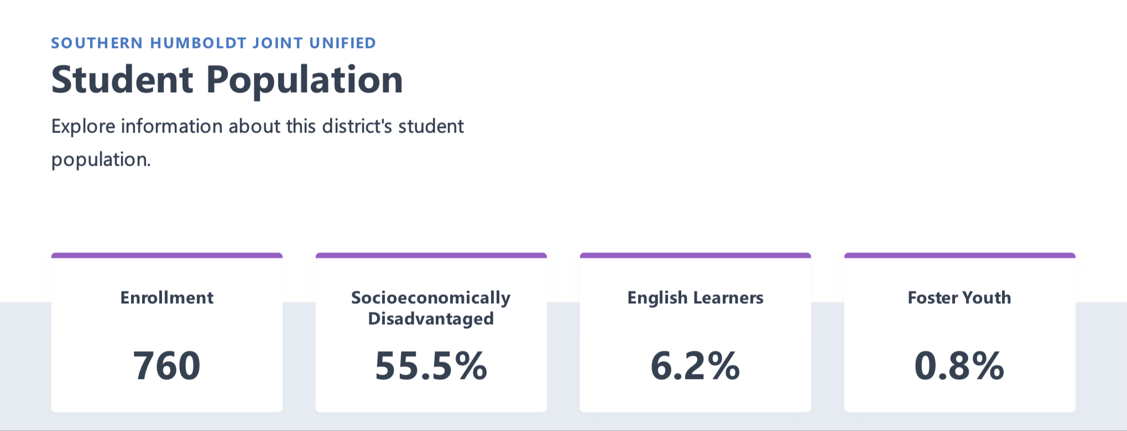
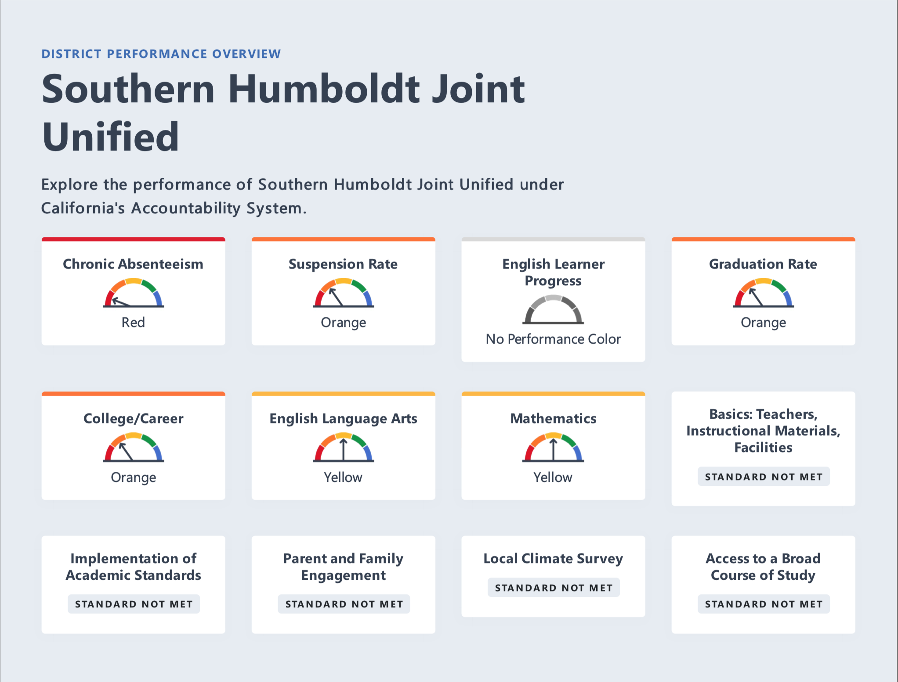
2019 California Dashboard

METHODOLOGY

The Civil Grand Jury conducted interviews that included local residents, local political leaders, some of the SHUSD Trustees, administrators of the Humboldt County Office of Education, and current and former SHUSD employees.
The Civil Grand Jury reviewed documents about the District and conducted Internet research. Minutes from the District and the Humboldt County Office of Education were reviewed.
Civil Grand Jury members attended, as observers, a community meeting intended specifically to discuss issues at the District.

DISCUSSION

Complaints

The Civil Grand Jury received the following complaints regarding the practices of the Southern Humboldt Unified School District (SHUSD):

- Nepotism
- Corruption
- Policies and procedures are not transparent
- Board is not answerable to the public
- Lack of due process for students and employees
- The Board acting unethically
- Concerns of staff and parents are being ignored by the Board
- Conflicts of interest by some Board members
- Superintendent and Principal do not know their jobs
- Board refuses to hear citizen complaints
- Lack of Board leadership
- Inadequately written Local Control and Accountability Plan ( LCAP)
- Failure to implement LCAP components (MTSS - Multi-tiered System of Supports, PBIS - Positive Behavioral Interventions and Supports, RTI - Response to Intervention)
- Discipline plan not being followed
- Lack of management accountability
- Administration not communicating with staff and parents
- Brown Act violation by the Board prohibiting a person from attending a public meeting
- Board censored a public member’s First Amendment right during a public meeting.

Civil Grand Jury members attended a community meeting specifically intended to discuss issues concerning the District. The Jury members noted the low attendance.
Issues raised included: affordable housing for teachers and staff, high employee turnover, and a host of concerns regarding curriculum. In many cases, teachers were not following the stated curriculum. Other complaints stated that the curriculum was inadequate for student needs. For example, there is a lack of Advanced Placement courses, as well as classes designed to help students get jobs upon graduation.
Community members also voiced concerns about staff accountability and consistency. The District has high employee turnover, thought to be due in part to teachers' need for a cost of living adjustment. The lack of clear policies regarding discipline and dispute resolution were frequently mentioned. Other issues include drugs in the District's schools, securing grant funding, and the need to use institutional memory to create a good learning environment.
Attendees also voiced concerns that the Board of Trustees is dismissive of community concerns.
The Civil Grand Jury was not able to confirm any acts of corruption or nepotism during its investigation. In a community with a small population, it is not unusual to find more than one family member employed in any organization. Few local residents are qualified for the certificated positions. The lack of housing opportunities and compensation levels limit interest from outside candidates for employment and retention of employees.

Discipline

Statements from complainants indicate that discipline procedures are not always followed. They allege a lack of due process and inconsistent application of those procedures. The administration, however, disagrees with this perspective.
The District has adopted a set of generic policies from the California School Boards Association. This is found on the District’s website, but the policies are awkward and difficult to interpret. A simplified set of school discipline matrices (last modified 2014) for elementary and secondary students is to be found on the District's website. Each school also provides information regarding student behavior in student handbooks.
When SHUSD developed their Local Control and Accountability Plan ( LCAP) they adopted stock language for; 1) Multi-tiered System of Supports (MTSS), 2) Positive Behavioral Interventions and Supports (PBIS), and 3) Response to Intervention (RTI). Each of these is a plan or program to help provide effective student discipline. However, these programs have not been applied sufficiently to reduce parent complaints.
The District is impacted from both a high suspension and chronic absenteeism. Chronic absenteeism was not quantified by the state until 2017. The California Department of Education says students are considered chronically absent if they are absent at least 10 percent of the instructional days that they were enrolled to attend in a school.

Information on the following chart is from the 2019 California Dashboard previously mentioned.

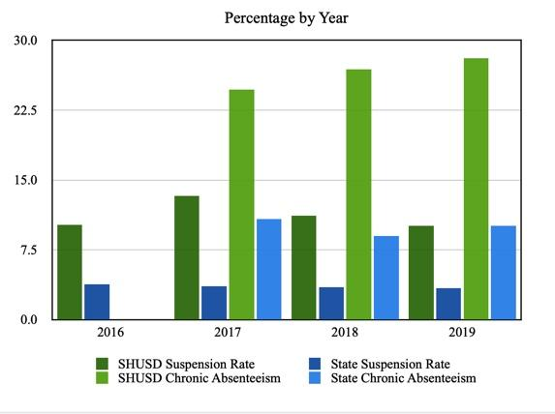

Leadership

People from the community, as well as administration, teachers, and staff, stated the SHUSD Board is operating outside their scope of responsibilities and micromanaging. A succession of District Superintendents has failed to provide leadership the Board needs.
The Civil Grand Jury identified two significant problems. The first problem was the failure by Board members to follow the guidelines governing their roles. A simple description of any school board’s role is: the School Board creates policy and governs through the policy it creates. Thus they are able to monitor and create policy pertinent to the needs of their schools.
The second significant problem was two-fold in regards to the Superintendent/Principal: the turnover of the position, as well as their failure to provide the necessary leadership the District needs to survive. Whether this shortened tenure or some other reason is responsible, the District has been deprived of an invested, enthusiastic, and effective leader.
The Superintendent manages the operations of the school system in accordance with School Board policies. The Superintendent of any school district is the driving factor for success. There are qualities that everyone will recognize as necessary for the position, such as leadership, vision and strategic thinking. One quality that is often overlooked is the ability to communicate. Good communication skills coupled with transparency and accessibility are essential to high student achievement. The Superintendent must be able to take information and synthesize it into compelling outcome goals and communicate those goals to the Board, teachers, students and administration.
It is the job of a school superintendent to help keep the Board focused on their appropriate role. This is a delicate task requiring effective communication and strong leadership. The first step to accomplish this is to ensure all parties are educated as to their roles and responsibilities.
The District’s current Superintendent/Principal, and a School Principal, will terminate their employment at the end of the 2019-2020 school year. This will provide an opportunity for the Board to hire a competent, energized, and visionary leader as Superintendent. Such a person can help the Board establish and maintain policy.

Funding

The future of SHUSD is dependent upon effective leadership at multiple levels, as well as improved funding. The District is primarily supported by the Local Control Funding Formula (LCFF), which is based on the number of students attending, rates varying by grade span (i.e; K-3, 4-6, 7-8, 9-12). Enrollment is declining due to multiple factors: changes in demographics, changes in the local economy, and students transferring to other schools that offer better programs. Absenteeism in the District, which has a negative effect on the school budget, was 28.1% versus 10.1% statewide in the 2018/2019 school year.
Methods to balance a school district budget are limited to only three areas where cuts can be made: Programs, People, and Sites.
- Programs - Many elective programs have been eliminated leaving mainly core programs.
- People - Last year the employees’ labor agreement did not include a raise. The employees recognized the financial situation and did not demand a raise. This is not the kind of action that can be repeated without damaging the District’s ability to recruit and retain qualified employees.
- Sites - Redway School has been updated and remodeled. This would allow the District to close Agnes J. Johnson and Whitethorn schools. Combining the students and staff in one location would reduce costs and improve the quality and types of education offered.
Athletic programs would disappear without parent fundraisers. This would negatively affect enrollment due to students transferring to schools that offer athletic programs. In the past, parents and the public have provided critical funding through donations, and fundraisers. Community-sourced funding has tapered off in recent years.
Between 1990 and 2004, seven California school districts slipped into financial insolvency; all were subsequently taken over by the State. This drastic financial solution, a state takeover, must be approved by the California Legislature. Over the past 30 years, multiple school finance reform acts have been passed by the Legislature in an effort to keep schools solvent. One of the many changes in law requires the State Office of Education and local county offices of education to provide oversight to school districts in order to prevent future school district financial failures.
It must be stressed that local school boards have a large degree of oversight regarding their district budget.

Charter School

In recent years, community members foresaw the closure of Agnes J. Johnson (AJJ) school and formed a coalition to turn that school into a charter school. Last year they petitioned the SHUSD Board for the charter but were denied on a vote of 3 to 2. The charter group then made an appeal to the Humboldt County Board of Education to establish a charter school, which was approved. The establishment of a Charter school through the Humboldt County Board of Education will have a negative financial impact upon the Southern Humboldt Unified School District.
The new charter school is called Agnes J. Johnson Charter School. It has contracted with SHUSD to occupy the AJJ school grounds. A Charter School independent from the Southern Humboldt Unified School District will not be eligible for transportation funding. This will cause increased financial strain on parents.

Failure to Provide for Open Meetings

The Board of Trustees have demonstrated a lack of openness to public meetings. In one instance the Board stopped a speaker at an open public meeting and suggested they would hear the issue in a closed session. At the ensuing closed session, the complainant was not in attendance. The Board hired an investigator to look at the issues in the complaint. The investigator found in favor of the complainant, yet the Board took no action.
In another instance, a member of the public was given a legal notice to stay off school grounds for 14 days. During that time period, a regularly scheduled Board meeting was held on a school campus. The member of the public in question asked for a waiver to attend the meeting and was denied. The Board voted 3 to 2 not to move the meeting to a location off school grounds. Failure to move the meeting or provide a waiver violated the intent of open meeting principles.

COUNTY OFFICE OF EDUCATION

The California Department of Education website describes county offices of education as follows:

There are 58 county offices of education that provide services to the state’s school districts. The county offices have elected governing boards and are administered by elected or appointed county superintendents.
The county superintendent is responsible for examining and approving school district budgets and expenditures. The passage of Assembly Bill 1200 (1991) gave the county superintendent additional powers to enforce sound budgeting to ensure the fiscal integrity of the district. The superintendent is also responsible for calling school district elections and assisting with school district emergencies by providing necessary services.
County offices of education support school districts by performing tasks that can be done more efficiently and economically at the county level. County offices provide or help formulate new curricula, staff development and training programs, and instructional procedures; design business and personnel systems; and perform many other services to meet changing needs and requirements. When economic or technical conditions make county or regional services most appropriate for students, county offices provide a wide range of services, including special and vocational education, programs for youths at risk of failure, and instruction in juvenile detention facilities.
In addition, several statutes now give county offices of education responsibility for monitoring districts for adequate textbooks, facilities, and teacher qualifications.

The Humboldt County Board of Education consists of five elected board members who are elected by the same districts as the Board of Supervisors. The Humboldt County School Superintendent is a county-wide elected position.
Each public school district is autonomous and run by a publicly-elected board. As described above, the Humboldt County Office of Education provides assistance and limited oversight but cannot intervene in local school board policy.
However, the state does require each county office of education to provide oversight of school district budgets.

FINDINGS

F-1. The Southern Humboldt Unified School District is in need of effective leadership with a clear vision from all stakeholders. (R-1, 2, 3, 4, 6, 8)
F-2. The Board of Trustees is in need of leadership with new ideas. (R- 1, 2, 3, 4, 6, 8)
F-3. There is a need for more community involvement in school-related issues and activities. (R-1, 3, 6)
F-4. Some Board members are either unfamiliar with or do not always adhere to the requirements of the Brown Act. (R-1, 4)
F-5. Discipline policy and procedures are not adhered to by the Board, administration, staff, parents and students. Therefore, discipline is not enforced consistently throughout the District. (R-5, 8)
F-6. Local economic downturn and declining student population within Southern Humboldt County in recent years has adversely affected the SHUSD finances. (R-6, 7, 8)
F-7. Southern Humboldt Unified School District is a geographically large district creating difficulty for serving the needs of students, parents and employees. (R-5, 6, 7, 8)
F-8. The Humboldt County Board of Education is required to provide oversight to school district budgets and intervene preemptively when necessary. SHUSD may be in need of intervention. (R-7, 8)
F-9. Establishment of a Charter school through the Humboldt County Board of Education will have a negative financial impact on Southern Humboldt Unified School District. (R-7, 8)
F-10. A Charter School, independent from the Southern Humboldt Unified School District will not be eligible for transportation funding. This will cause increased financial strain on parents.
F-11. The Civil Grand Jury was unable to identify specific instances of nepotism or corruption.
F-12. The region has a small trained labor pool which limits Southern Humboldt Unified School District’s recruitment and retention options. (R-6, 8)

RECOMMENDATIONS

R-1. The Humboldt County Civil Grand Jury recommends the Southern Humboldt Unified School District Board of Trustees offer a public information meeting. This meeting will engage and educate the public on how to become more involved in activities of the school board, including considering running for a seat on the school board. The meeting should be held before November 1st, 2020. (F-1, 2, 3, 4)
R-2. The Humboldt County Civil Grand Jury recommends the Southern Humboldt Unified School District Board of Trustees articulate and publish a clear vision for the future of the District. This process should be completed by the beginning of spring semester 2021. (F-1, 2)
R-3. The Humboldt County Civil Grand Jury recommends the Southern Humboldt Unified School District Board of Trustees create an easy-to-navigate section on the District website detailing how to become a board member, as well as the need for citizen participation. This portion of the website should be completed by November 1, 2020. (F-1, 2, 3)
R-4. The Humboldt County Civil Grand Jury recommends the Southern Humboldt Unified School District Board of Trustees attend training regarding their legal responsibilities to the community, including the Brown Act, and establish a policy that all new board members attend such training. Cost of the seminars to be covered by the District. The training and new policy should be completed by November 1, 2020. (F-1, 2, 4)
R-5. The Humboldt County Civil Grand Jury recommends discipline policy and procedures be standardized throughout the Southern Humboldt Unified School District and implemented in a consistent manner. Training regarding discipline should be provided to all personnel of the District, classified, certificated, and volunteers. These training sessions should be open to the public. Training should be completed by November 1, 2020. (F-5, 7)
R-6. The Humboldt County Civil Grand Jury recommends the Southern Humboldt Unified School District must more aggressively pursue creative funding ideas from a variety of sources, including federal and state grants, charitable donations from private businesses, and local benefactors. The Board should make an announcement about their search for community volunteers to spearhead the fundraising efforts. The announcement should be made on local media, inviting public participation. After the fundraising personnel are announced, the Board will work closely with them, keeping in mind their common goals. The Board should then instruct the Superintendent to write an annual report detailing these fundraising efforts. This report should be produced for the public no later than June 1 of every school year. (F-1, 2, 3, 6, 7, 12)
R-7. The Humboldt CountyCivil Grand Jury recommends that the Humboldt County Office of Education become more proactive in its responsibility to examine and approve the Southern Humboldt Unified School District budget. Budget oversight should be ongoing. HCOE should collaborate with the District, effective at the start of 2020/2021 school year. (F-6, 7, 8, 9)

R-8. The Humboldt County Civil Grand Jury recommends that the Humboldt County Office of Education perform an intervention with Southern Humboldt Unified School District in order to assist the District in achieving financial stability, a district-wide positive behavior program, and academic rigor. These efforts are to be ongoing, with implementation starting by the start of the 2020/2021 school year. (F-1, 2, 5, 6, 7, 8, 9, 12)

REQUEST FOR RESPONSES

Pursuant to Penal Code section 933.05, the Grand Jury requests responses as follows:
Southern Humboldt Unified School District Board of Trustees (F-1, F-2, F-3, F-4, F-5, F-6, F-7, F-8, F-9, F-12, R-1, R-2, R-3, R-4, R-5, R-6)
Humboldt County Board of Education (F-8, F-9, R-7, R-8)

Humboldt County Schools Superintendent (F-8, F-9, R-7, R-8)

INVITED RESPONSES

None

Reports issued by the Grand Jury do not identify individuals interviewed. Penal Code section 929 requires that reports of the Grand Jury not contain the name of any person or facts leading to the identity of any person who provides information to the Grand Jury

BIBLIOGRAPHY

2019 California Dashboard, Accessed 18 April 2020, https://www.caschooldashboard.org/reports/12630400000000/2019

The Bond Buyer, Ten Years After Chapter 9, Vallejo Looks Ahead, 17 May 2018, https://www.washingtonpost.com/business/economy/vallejo-calif-once-bankrupt-is-now-a-model-for-cities-in-an-age-of-austerity/2012/05/23/gJQAjLKglU_story.html

California Charter School Association, “Conversion Charter Schools: A Closer Look,” Accessed 18 April 2020, http://library.ccsa.org/2012/04/conversion-charter-schools-a-closer-look.html

California Department of Education, “Local Control Funding Formula Overview,” Accessed 18 April 2020, https://www.cde.ca.gov/fg/aa/lc/lcffoverview.asp

California Office of Education, County Office of Education, Accessed 18 April 2020, https://www.cde.ca.gov/re/sd/co/coes.asp

California School Board Association, Governing to Achieve, 7 August 2014

SFGate, VALLEJO/Bankrupt School District to Seek $60 Million State Loan, 17 April 2004, https://www.sfgate.com/education/article/VALLEJO-Bankrupt-school-district-to-seek-60-2792182.php

Southern Humboldt Unified School District website, Accessed 18 April 2020, https://sohumusd.com/

Southern Humboldt Unified School District Board Policies, Accessed 18 April 2020, http://www.gamutonline.net/district/southernhumboldt/

Vallejo Times-Herald, Vallejo Schools Exiting State Control on Monday, 7 April 2013, https://www.timesheraldonline.com/2013/04/07/vallejo-schools-exiting-state-control-on-monday
Washington Post, Vallejo, Calif., once Bankrupt, Is Now a Model for Cities in an Age of Austerity, 23 May 2012, https://www.washingtonpost.com/business/economy/vallejo-calif-once-bankrupt-is-now-a-model-for-cities-in-an-age-of-austerity/2012/05/23/gJQAjLKglU_story.html
North Coast Journal, Humboldt, Calif., Turmoil Continues in SoHuM School District, 11 October 2019, Last Accessed 21 April 2020, https://www.northcoastjournal.com/NewsBlog/archives/2019/10/11/turmoil-continues-in-sohum-school-district
North State Public Radio, School Closures: A Growing Problem in Rural California, by Adia White, 24 June 2018, Last Accessed 21 April 2020, https://www.mynspr.org/post/school-closures-growing-problem-rural-california#stream/0
First Amendment Coalition, Brown Act Primer, Last Accessed 21 April 2020, https://firstamendmentcoalition.org/facs-brown-act-primer/
National Schools Public Relations Association, Characteristics of a Superintendent, Last Accessed 21 April 2020, https://www.nspra.org/files/docs/CharacteristicsOfEffectiveSuperintendents.pdf
Southern Humboldt Unified School District, Agendas and Minutes, Last Accessed 21 April 2020, https://agendaonline.net/public/sohumusd
California Department of Education, County Offices of Education, Last Reviewed 14 February 2020, Last Accessed 22 April 2020, https://www.cde.ca.gov/re/sd/co/coes.asp

