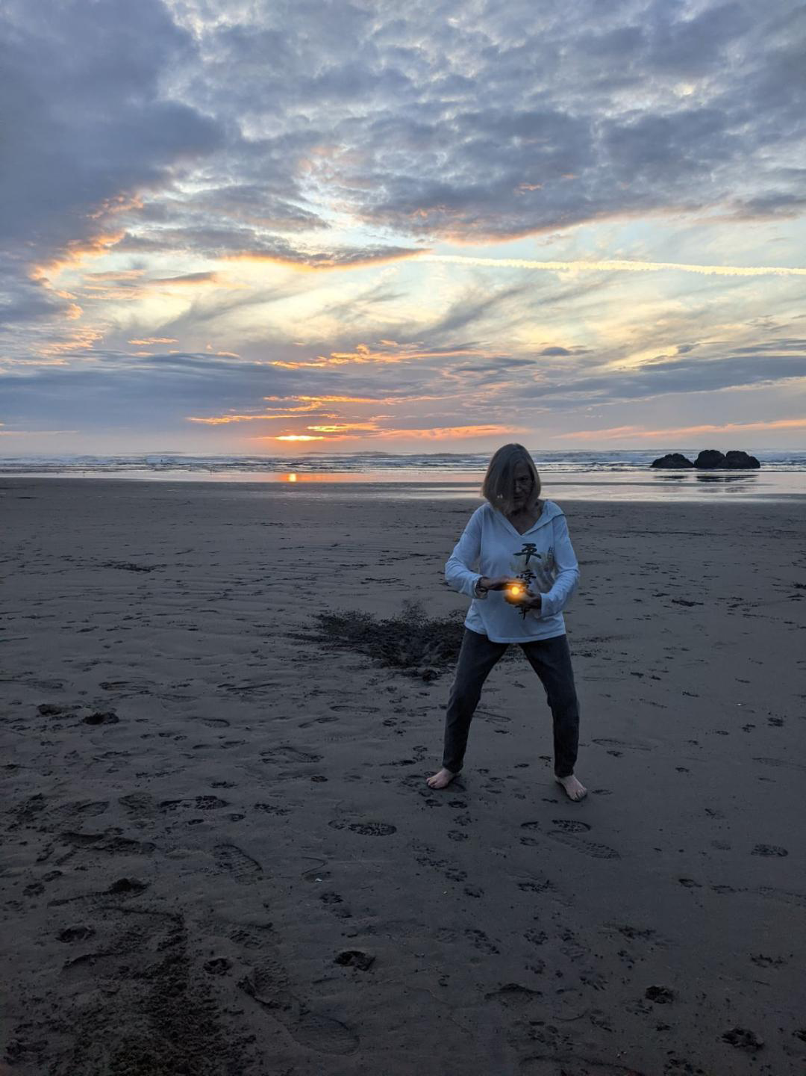
Moonstone Tai Chi/Qi Gong
Tai Chi by
The Sea

Wednesdays 4:00 to 5:30 PM
$20 for 90 Minutes
Call Glenda at (707)268-3936

